Round 1 – Current Affairs - Timewarp

- Which province joined the confederation of Canada in July 1871?
- In July of which year was Tony Blair declared the winner of the leadership election of the Labour Party?
- In July 1960 Sirimavo Bandaranaike became the first woman prime minister in the world – which country was she leader of?
- Born in July 1963, which Spanish footballer scored 26 goals for his country and was known by the nickname El Buitre (The Vulture)?
- In July of which year did Prince Andrew, Duke of York marry Sarah Ferguson at Westminster Abbey?
- In which ocean did Apollo 11 splashdown after successfully landing on the Moon in July 1969?
- Cyclist Lance Armstrong won his first Tour de France in July of which year?
- Horatio Nelson lost his right arm during a failed July 1797 attempt to conquer which Spanish island?
- In July of which year was the first V-2 Rocket attack on Great Britain?
- What was the surname of the famous American statistician and opinion pollster who died on July 26th 1984?

Round 2 –General Knowledge

- Which ancient Greek physician is often referred to as "The Father of Medicine"?
- Which rock opera features the song ‘Pinball Wizard’?
- Which citrus fruit is created by hybridizing a grapefruit and a tangerine?
- Which flower bears the name of the Greek mythological figure who fell in love with his own reflection?
- Which UK county cricket club plays its home matches at Sophia Gardens?
- Who succeeded Carol Ann Duffy in as Poet Laureate in May 2019?
- Who holds the record for most games managed in the Premier League?
- What phobic term is typically used to describe a fear or dislike of foreigners or in general of people different from one's self?
- Which singer and actor was born Terence Nelhams-Wright?
- The Temple of Angkor Wat features on the flag of which Country in Southeast Asia?

Round 3 –Gimme 5

Name the five US states with the longest coastline.

Round 4 –Connections

- Who, in 1994, took over from Richard O’Brien as presenter of ‘The Crystal Maze?
- Which former footballer had the nickname “Psycho”?
- Which actor played the part of Battery Sergeant Major Williams in the 1970s/1980s British sitcom ‘It Ain't Half Hot Mum’?
- Which is the largest city on the banks of the river Leine in Germany?
- What is the connection?

Round 5 –General Knowledge

- Liverpool FC won a nineteenth League title in 2020, the club's first during the Premier League era.- who is their club captain?
- What is the highest value euro note in circulation?
- Who was the world’s first head of government to give birth whilst in office?
- In which city would you find Grauman's Chinese Theatre (currently known under naming rights as TCL Chinese Theatre)?
- Which ‘Carry On’ movie chronicled events of 1492?
- Footballing legend Jack Charlton passed away in July 2020, which town in Northumberland was he born and bred in?
- Who shot and killed John Lennon in 1980?
- Which chart topping singer was born Enrique Morales?
- What is the name of the USA’s national military cemetery?
- In which country did Pernod originate?

Round 6 – Music

- What is the title of the French National Anthem?
- How is the duo of David Peacock and Charles Hodges better known?
- Who wrote the script, music and lyrics for the critically acclaimed musical ‘Hamilton’?
- Who wrote the song The Byrds hit `Mr Tambourine Man`?
- Which crooner sang the theme tune for the Bond film `From Russia With Love`?
- Which soap actor had a top ten hit with `Mona` in 1990?
- Who composed the opera `The Magic Flute`?
- Who was the lead singer with the band Thin Lizzy?
- Which Canadian singer released the worldwide hit album ‘After Hours’ in March 2020?
- Which group had hits in the 80s with `Harvest For The World` and `Ideal World`?

Round 7 –Who Am I?

10 Points – I am an American actor born on July 17, 1952 in Baltimore, Maryland.

8 Points – My first major role was portraying Dr. William "Snapper" Foster, Jr. on the soap opera ‘The Young and the Restless’ from 1975-82.

6 Points – I had a number-one hit in the German pop charts in 1989.

4 Points – I famously appeared performing my German No 1 single "Looking for Freedom" at the Berlin Wall on New Year's Eve 1989.
I was one of the judges on ‘America’s Got Talent’ from 2006 to 2009 and, in 2011, I joined the panel of ‘Britain’s Got Talent’ staying for one season.

2 Points – I am perhaps best known for my roles as Michael Knight in the TV series ‘Knightrider’ and as Mitch Buchannon in ‘Baywatch’.
My nickname is “The Hoff”

Note to quizmaster – Who am I? should be the last round played after the final sub-totals have been announced. This round gives every team the opportunity to win 10 points at the end, and to maybe snatch the top prize at the death. Each team has only one opportunity to hand an answer in, getting the relevant number of points for a correct answer, but zero points for an incorrect answer. Each team should only get one go, with the correct answer not announced until every team has handed their sheet in.

Jackpot/Tiebreak Questions

- Arsène Wenger holds the record for the most games managed in the Premier League, all with Arsenal – how many did he do?
- If you add up the totals – how many ‘Carry On’ films have Kenneth Williams, Joan Sim, Charles Hawtrey and Sid James been in?

Answer Sheets / Score Sheet

Round 1 Answers

- British Columbia
- 1994
- Sri Lanka (Ceylon)
- Emilio Butragueno
- 1986
- Pacific Ocean
- 1999
- Tenerife
- 1944
- Gallup

Round 2 Answers

- Hippocrates
- ‘Tommy’
- Ugli fruit
- Narcissus
- Glamorgan
- Simon Armitage
- Arsene Wenger
- Xenophobia
- Adam Faith
- Cambodia

Round 3 Answers

- Alaska 6,640 miles
- Florida 1,350 miles
- California 840 miles
- Hawaii 750 miles
- Louisiana 397 miles

Round 4 Answers

- Ed Tudor-Pole
- Stuart Pearce
- Windsor Davies
- Hanover
- Royal Dynasty’s / Houses (UK rulers)

Round 5 Answers

- Jordan Henderson
- 500 Euro note
- Benazir Bhutto
- Los Angeles
- ‘Carry On Columbus’
- Ashington
- Mark Chapman
- Ricky Martin
- Arlington
- France

Round Six Answers

- La Marseillaise
- Chas and Dave / Chas 'n' Dave
- Lin-Manuel Miranda
- Bob Dylan
- Matt Monro
- Craig McLachlan
- Mozart
- Phil Lynott
- The Weeknd
- The Christians

Who Am I?

- Correct answer is David Hasselhoff

Tiebreak/Jackpot Answers

- 828 – He broke the record set by Alex Ferguson, who had managed 810 games with Manchester United from the Premier League's inception to his retirement at the end of the 2012–13 season.
- 92 (Williams 26, Sims 24, Hawtrey 23, James 19)

Team Name

_________________________________________

Round One – Current Affairs TW
1
2
3
4
5
6
7
8
9
10
Round Two –Gen Knowledge
1
2
3
4
5
6
7
8
9
10
Round Three –Gimme Five
1
2
3
4
5
Round Four - Connections
1
2
3
4
And the Connection is…
5
Round Five –General Knowledge
1
2
3
4
5
6
7
8
9
10
Round Six – Music
1
2
3
4
5
6
7
8
9
10
Final Round –Who Am I?
Round One Score
Round Two Score
Round Three Score
Round Four Score
Round Five Score
Round Six Score
Final Round Score
Total Score
Tiebreaker Answer (if needed)

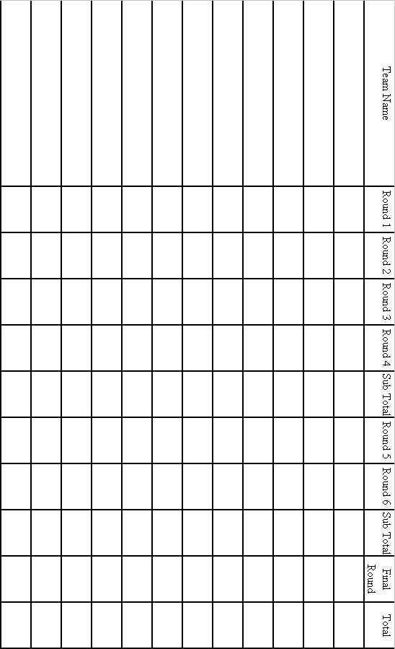
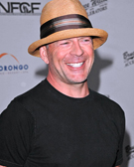  1__________________ | 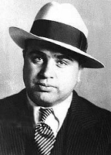  2________________ |   3__________________
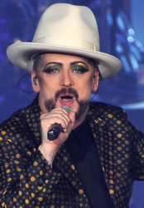  4__________________ | 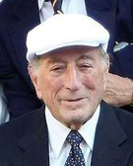  5__________________ |   6__________________
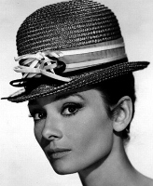  7__________________ | 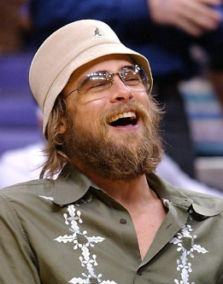  8__________________ | 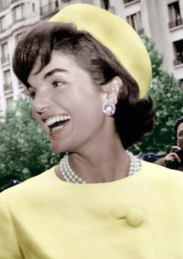  9__________________
  10__________________ |   11__________________ | 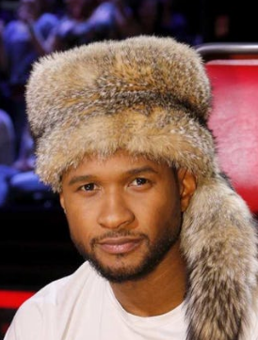  12_________________
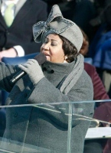  13__________________ | 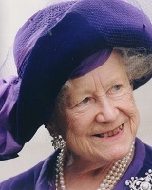  14__________________ | 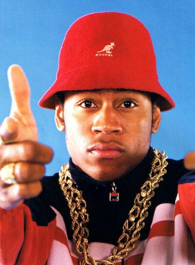  15_________________
  16__________________ | 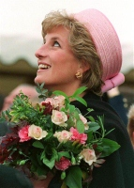  17__________________ | 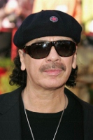  18______________________

Answers

- Bruce Willis
- Al Capone
- Victoria Beckham
- Boy George
- Tony Bennett
- Sarah Jessica Parker
- Audrey Hepburn
- Brad Pitt
- Jackie Kennedy Onassis
- Benecio Del Toro
- Madonna
- Usher
- Aretha Franklin
- Queen Elizabeth the Queen Mother
- LL Cool J
- Christina Aguilera
- Diana, Princess of Wales
- Carlos Santana

Table Round – Brit of a Do!

Can you identify these groups who have won ‘Best British Group’ at the Brit Awards just from their initials and the year?– one point for naming each group.

1 | AM (2008)
2 | DS (1986)
3 | TB (1977)
4 | T (2000)
5 | SR (1993)
6 | FS (1987)
7 | F (2020)
8 | KC (2006)
9 | MSP (1997)
10 | RB (2015)
 |  | Total Score (out of 10) -

Answers

- Arctic Monkeys
- Dire Straits
- The Beatles
- Travis
- Simply Red
- Five Star
- Foals
- Kaiser Chiefs
- Manic Street Preachers
- Royal Blood

Speed Round

The clock is ticking… 24 different actors and actresses have completed the Triple Crown of Acting, that is winning a competitive Academy Award, Emmy Award and Tony Award in the acting categories – name them!
One point for each correct answer.

1 | 2 | 3 | 4
5 | 6 | 7 | 8
9 | 10 | 11 | 12
13 | 14 | 15 | 16
17 | 18 | 19 | 20
21 | 22 | 23 | 24
 |  | Total Score (out of 24) -

Note to quizmaster – Timing is everything with this round to ensure fairness and to create some manic brainstorming! Stipulate that teams have a set short amount of time in which to complete this round, and make sure that all teams begin at exactly the same time, and finish at exactly the same time. Three or four minutes normally works very well on this round, and sealing the sheets in an envelope ensures all teams begin at exactly the same time. Award one point for each correct answer, the winning team will have the most answers correct.

Answers

- Al Pacino
- Anne Bancroft
- Christopher Plummer
- Ellen Burstyn
- Frances McDormand
- Geoffrey Rush
- Glenda Jackson
- Helen Hayes
- Helen Mirren
- Ingrid Bergman
- Jack Albertson
- Jason Robards
- Jeremy Irons
- Jessica Lange
- Jessica Tandy
- Maggie Smith
- Maureen Stapleton
- Melvyn Douglas
- Paul Scofield
- Rita Moreno
- Shirley Booth
- Thomas Mitchell
- Vanessa Redgrave
- Viola Davis

Complimentary Music Quiz

Every week our Full Monty quiz comes complete with a free music round for you to use alongside your other quizzes supplied above. The mp3 quiz file contains 10 mixed or themed tracks and is automatically supplied as a free additional download item when you place your Full Monty order.

You must download the music round within 48 hours of placing your order.

Music quiz answers

- The Weeknd - Blinding Lights
- Kool & The Gang - Jungle Boogie
- No Doubt - It's My Life
- Celine Dion - Think Twice
- Jonas Brothers - What A Man Gotta Do
- Climie Fisher - Love Changes (Everything)
- LMFAO - Sexy And I Know It
- The Partridge Family - It's One Of Those Nights (Yes Love)
- Steppenwolf - Magic Carpet Ride
- Freya Ridings - Love Is Fire

